2. <jsp:include>=> include request Dispatching mechanism.

<jsp:forward>=> forward request Dispatching mechanism.

Eg: ForewardIncludeActionsJsp

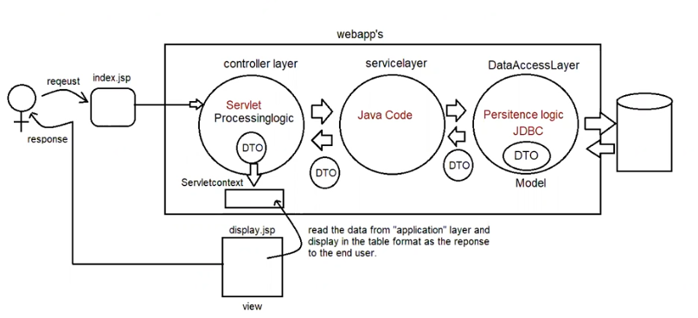

Eg:ParamJspActions

<jsp:param name = " value=''"> => To add new values to request object and send it to the respective page we use

<jsp:param name = " value="/>

deprecated jsp actions are

<jsp:plugin>

<jsp:fallback>

<jsp:params>

Customactions

===========

These are the actions which are developed by developers as per their application requirements.

In jsp two types of tags are available

a. standardactions -> predefined tags known to container

b. customactions -> inform explicitly to the container.

To prepare custom tags in Jsp pages we use the following syntax.

<prefix_name:tag_name>

;;;;;;;;

;;;;;;;;

;;;;;;;;

</prefix_name:tag_name>

If we want to design custom tags in our jsp application, then we use the following 3 elements

a. jsp page with taglib directive

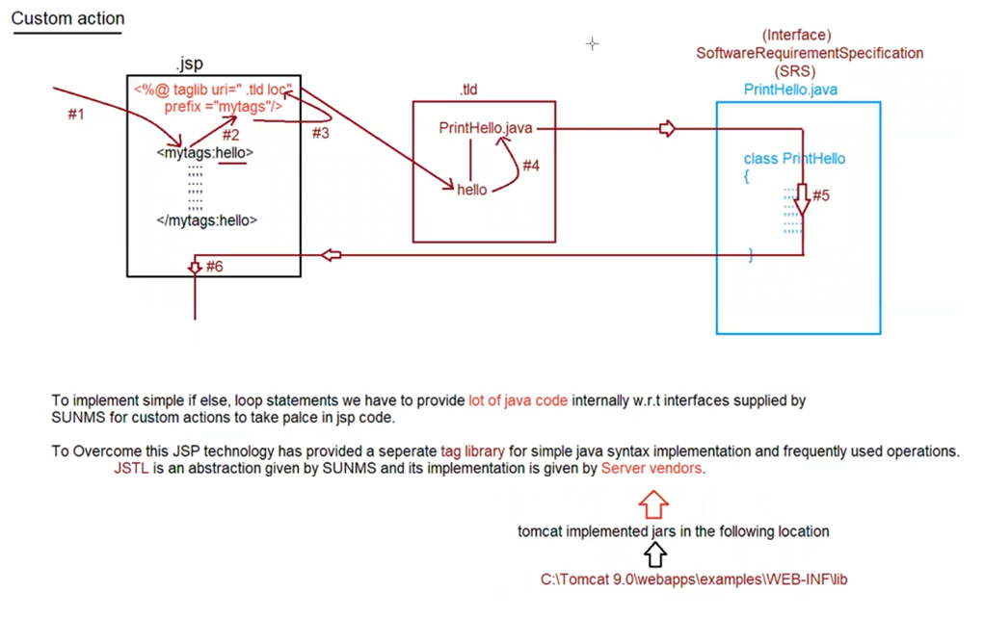

Eg: CustomActionsJsp